TASK 4 :
class Solution {
public int[] getSumAbsoluteDifferences(int[] nums) {
int n = nums.length;
int[] prefix = new int[n];
int[] res = new int[n];

// build prefix sums
prefix[0] = nums[0];
for (int i = 1; i < n; i++) {
prefix[i] = prefix[i - 1] + nums[i];
}

int total = prefix[n - 1];

for (int i = 0; i < n; i++) {
int leftSum = (i > 0) ? prefix[i - 1] : 0;
int rightSum = total - prefix[i];

int left = nums[i] * i - leftSum;
int right = rightSum - nums[i] * (n - i - 1);

res[i] = left + right;
}

return res;
}
}
Case1: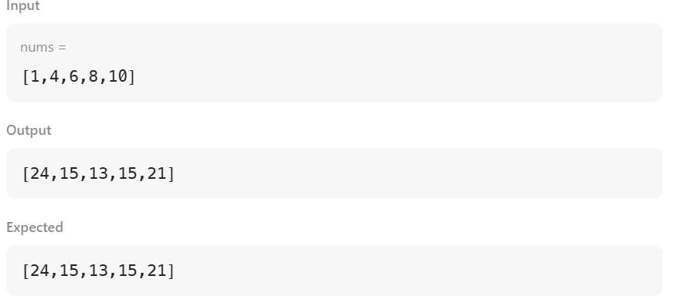
Case2:
